CodeAlpha Data Analytics Internship
Task 3: Data Visualization
Project Title
Superstore Sales Dashboard using Power BI

Objective :-
The objective of this project is to transform raw sales data into meaningful visualizations that help understand business performance. The dashboard presents sales trends, profit analysis, regional performance, and product insights using interactive Power BI visuals.

Dataset Used :-
Dataset Name : Sample Superstore Dataset
The dataset contains retail sales records including customer information, product categories, regions, sales, profit, quantity, discounts, and shipping details.

Tool Used :-
- Microsoft Power BI Desktop
- Power Query
- DAX (Data Analysis Expressions)
- Sample Superstore Dataset (CSV)

Visualizations Created :-
The following visualizations were designed to represent the data clearly:
Visualization | Purpose
KPI Cards | Display Total Sales, Total Profit, Quantity, Average Profit, and Discount Amount
Line Chart | Show monthly Sales and Profit trends
Pie Chart | Compare Sales by Category
Donut Chart | Display Sales by Region
Treemap | Show Sales by Sub-Category
Matrix Table | Display Product Details and Sales Information
Slicers | Filter data by Category, Segment, Region, State, Ship Mode, and Sub-Category

Dashboard Design :-
The dashboard was designed with:
- A clean and professional layout.
- KPI cards at the top for quick business insights.
- Charts arranged for easy comparison.
- Interactive slicers for filtering data.
- Consistent formatting and colors.
- Easy navigation between dashboard pages.

Insights from the Dashboard
The dashboard provides the following insights:
- Technology category contributes the highest sales.
- West region generates the highest sales.
- Sales increase during the last quarter of the year.
- Standard Class is the most commonly used shipping mode.
- Phones are among the highest-selling sub-categories.
- Consumer segment contributes a significant share of revenue.
- Sales and profit trends help identify seasonal business patterns.
- Interactive filters allow users to analyze data by region, category, and customer segment.

How the Dashboard Supports Decision-Making
The dashboard helps business managers to:
- Monitor overall sales performance.
- Compare regional sales and profit.
- Identify top-performing product categories.
- Track monthly sales trends.
- Analyze customer segments.
- Make informed business decisions using interactive filters.

Portfolio Value :-
This dashboard demonstrates skills in:
- Data visualization
- Dashboard design
- Business intelligence
- Power BI
- DAX measures
- Interactive reporting
- Data storytelling
It can be included in a professional portfolio to showcase practical data analytics skills.

Conclusion :-
The Superstore Sales Dashboard successfully converts raw sales data into meaningful visual insights. The interactive dashboard enables users to understand business performance, identify trends, compare categories and regions, and support data-driven decision-making.
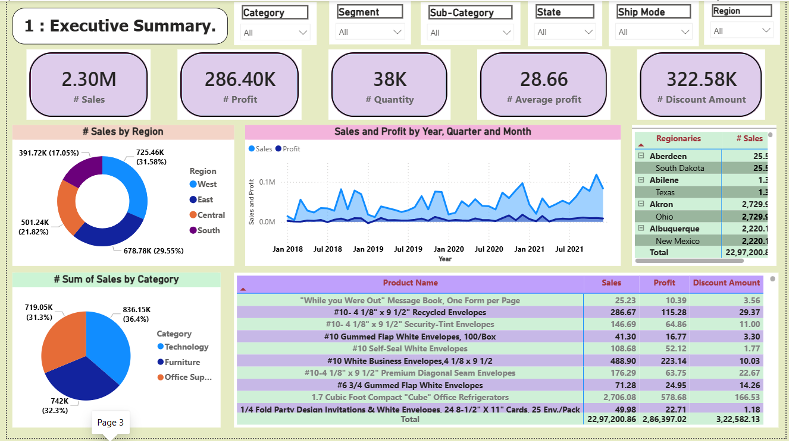

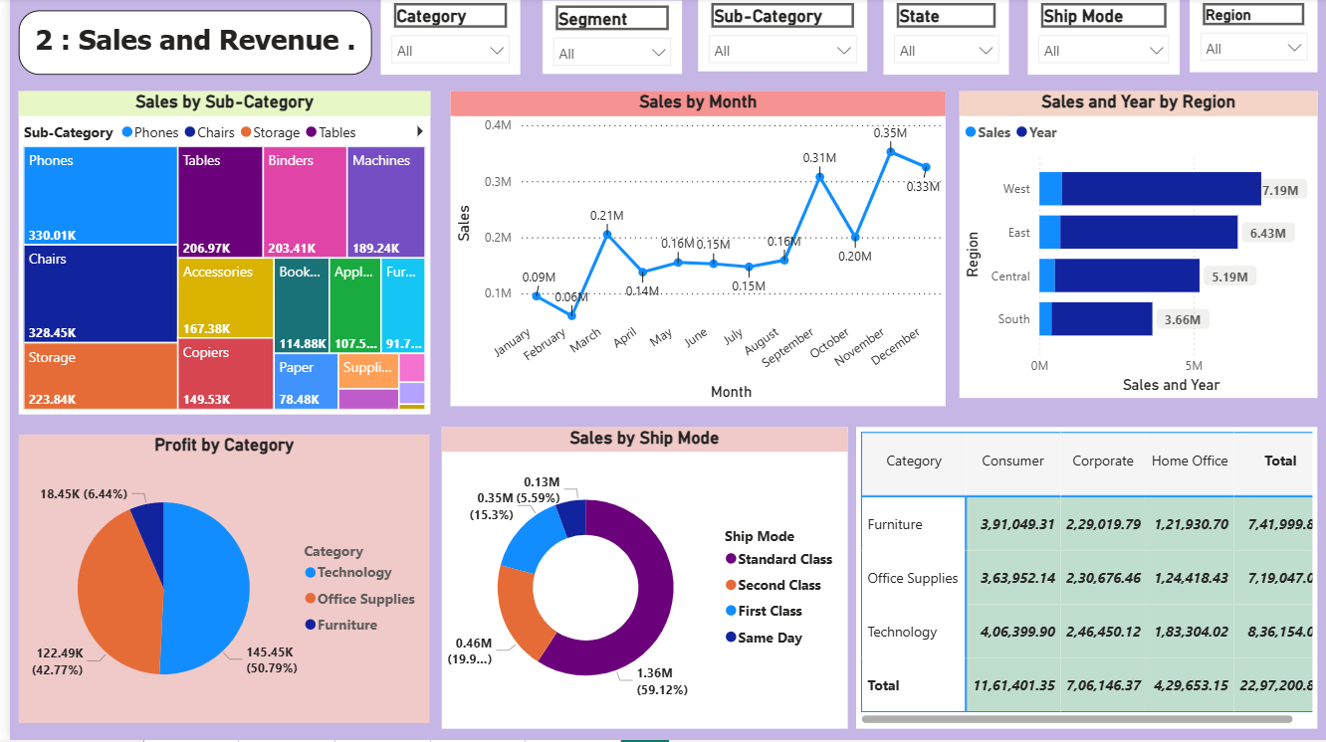

Thank You!

